Department of Computer Science and Engineering

CSA06 – Design and Analysis of Algorithms
CO1 – Assessment Tool 1
IT Application-Based Problem Solving
Scalability Audit of an E-Commerce Platform
(Case Study: “ShopSphere” Online Shopping Platform)
Course Code & Name | CSA06 – Design and Analysis of Algorithms
Assessment | CO1 – Assessment Tool 1: IT Application-Based Problem Solving
Course Outcome Assessed | Determine algorithm efficiency using asymptotic notations and mathematical techniques including Master Theorem and substitution method.
Duration | 3 Days
Mode | Individual
Student Reg. No. | 192521361
Student Name | Divya Prashanth S

Part (a): Understand the Problem

Question (a)
Understand the Problem: For each of the five modules, identify the input size and the basic operation that dominates the running time, explain where it occurs, and state how you expect its execution count to grow as n increases. Justify each choice briefly.

Solution

Module | Input size | Basic operation and where | Expected growth | Justification
M1 | n products | Title and seller comparison in the IF of the inner loop | Quadratic, about n²/2 | Runs once per pair of products
M2 | n (request array size) | Audit(Request[j]) in the inner FOR | Linear | Doubling sum, dominated by the last pass
S1 | n products | Key comparison in the scan loop | Linear | One comparison per product examined
S2 | n index entries | Key vs middle entry, once per halving | Logarithmic | Range halves each comparison
M4 | n records | Merging one record at each recursion node | Current: n². Redesign: n log n | 4 sub-problems of n/2 vs 2 sub-problems of n/2
M5 | n sales records | Revenue comparison in the sort at each level | n log² n | n log n sort repeated on log n levels
Report | n products | Operation in the nested loops giving 3n² | Quadratic | 3n² dominates the other terms

Part (b): Analyse the Iterative Modules
Question (b)
Analyse the Iterative Modules: For M1, derive the exact number of comparisons as a function of n and state the time and space complexity. For M2, derive the exact number of Audit operations, decide whether the team member’s Θ(n log n) claim is correct and give the tight bound. Verify your M2 result for n = 1,024.
Solution
M1
Inner loop for a given i runs n − 1 − i times
C(n) = (n − 1) + (n − 2) + … + 1 = n(n − 1)/2
Time: Θ(n²) in best, average and worst case (no early exit). Space: O(1).
M2
i = 1, 2, 4, …, 2^{k−1}, where k = ⌈log₂ n⌉ passes
A(n) = 2⁰ + 2¹ + … + 2^{k−1} = 2^{⌈log₂ n⌉} − 1
n − 1 ≤ A(n) < 2n − 1 ⟹ A(n) = Θ(n)
Claim Θ(n log n) is incorrect. The inner loop runs i times (not n), and i doubles, so the sum is geometric and dominated by the last pass. Tight bound: Θ(n), space O(1).
Verification for n = 1,024
Passes: i = 1, 2, 4, …, 512 (10 passes).
1 + 2 + 4 + 8 + 16 + 32 + 64 + 128 + 256 + 512 = 1,023 = 2¹⁰ − 1 = n − 1 ✓

Part (c): Solve a Recurrence by Substitution
Question (c)
Solve a Recurrence by Substitution: Solve the recurrence for search version S2 using backward substitution, showing every intermediate step, and derive the exact closed form. State the time complexity and the space complexity of both an iterative and a recursive implementation.
Solution
T(n) = T(n/2) + 1, T(1) = 1
T(n) = [T(n/4) + 1] + 1 = T(n/4) + 2
T(n) = [T(n/8) + 1] + 2 = T(n/8) + 3
After k steps: T(n) = T(n/2^{k}) + k
n/2^{k} = 1 ⟹ k = log₂ n
T(n) = T(1) + log₂ n = 1 + log₂ n
Exact closed form: T(n) = ⌊log₂ n⌋ + 1 (for n = 1,000,000 this is 20).
Implementation | Time | Space | Reason
Iterative | Θ(log n) | O(1) | Only low, high, mid stored
Recursive | Θ(log n) | O(log n) | One stack frame per halving

Part (d): Apply the Master Theorem
Question (d)
Apply the Master Theorem: For M4, apply the Master Theorem to both the current design and the proposed redesign, clearly identifying a, b, f(n), n^(log_b a) and the case used, and explain what happens to the running time when the data doubles. For M5, determine whether any of the three standard cases applies to T(n) = 2T(n/2) + n log n; if not, derive the complexity using the extended Master Theorem or a recursion tree.
Solution
M4
Design | a | b | f(n) | n^(log_b a) | Case | Result
Current: 4T(n/2) + n | 4 | 2 | n | n² | 1 (f(n) = O(n^{2−ε})) | Θ(n²)
Redesign: 2T(n/2) + n | 2 | 2 | n | n | 2 (f(n) = Θ(n)) | Θ(n log n)

Data doubles: current T(2n) ≈ 4·T(n), so the time becomes 4 times. Redesign T(2n) = 2T(n) + 2n, so the time becomes slightly more than 2 times.
M5: T(n) = 2T(n/2) + n log n
a = 2, b = 2, n^(log_b a) = n, f(n) = n log n.
- Case 1: needs f(n) = O(n^{1−ε}). Fails, since n log n grows faster than n.
- Case 2: needs f(n) = Θ(n). Fails.
- Case 3: needs f(n) = Ω(n^{1+ε}). Fails, since (n log n)/n^{1+ε} = log n / n^{ε} → 0.
No standard case applies. Extended Case 2 with k = 1:
T(n) = Θ(n · log¹⁺¹ n) = Θ(n log² n)
Recursion tree check: level i costs n(log n − i), so T(n) = n·log n(log n + 1)/2 + n = Θ(n log² n).
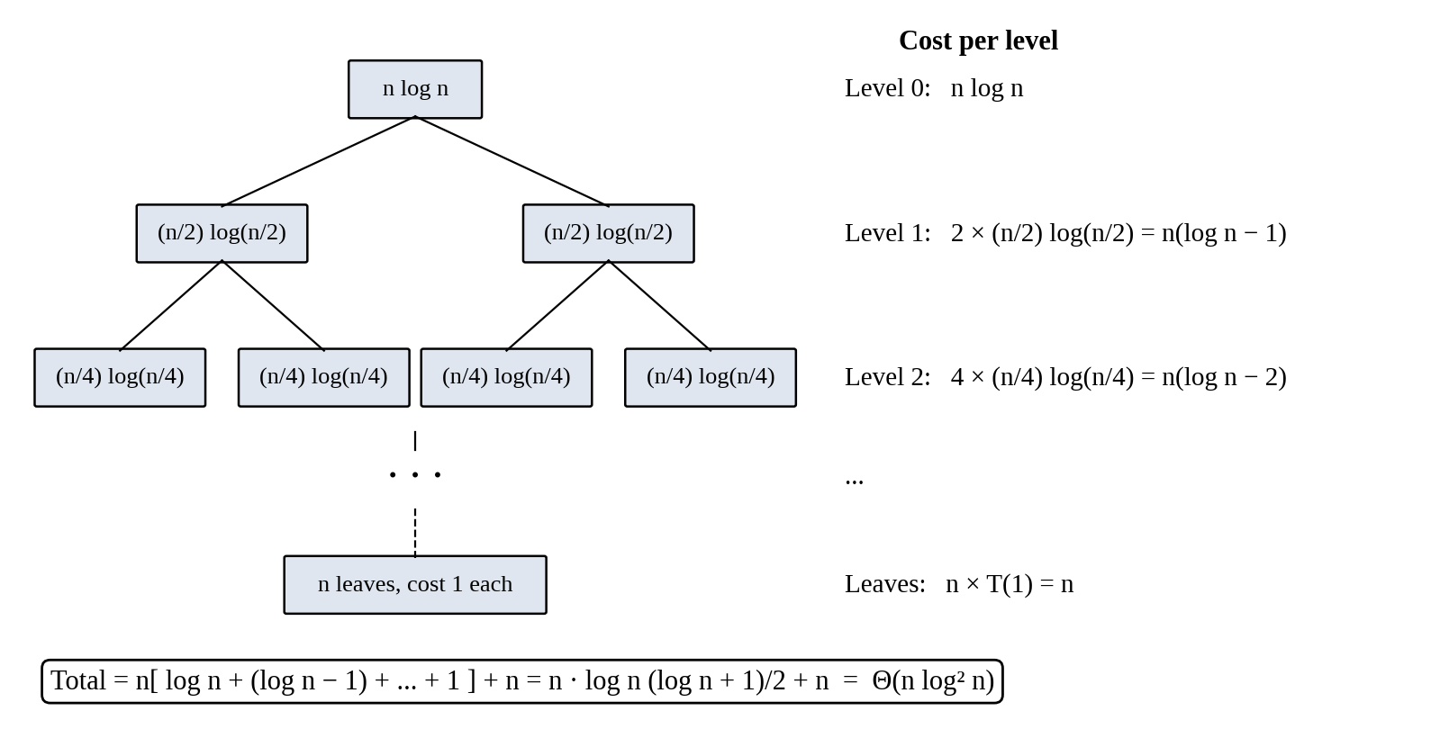
Figure 1: Recursion tree for M5Part (e): Analyse Best, Average and Worst Cases
Question (e)
Analyse Best, Average and Worst Cases: For search versions S1 and S2, identify the input condition that produces the best, average and worst case and give the number of comparisons in each. For S1, derive the average number of comparisons when the probability that the searched product exists is p, and evaluate it for n = 1,000,000 and p = 0.5.
Solution
Case | S1 condition | S1 comparisons | S2 condition | S2 comparisons
Best | Key is the first item | 1 | Key is the middle entry | 1
Average | Key present with probability p, uniform position | p(n + 1)/2 + (1 − p)n | Key present at any position | ≈ log₂ n − 1
Worst | Key is last or absent | n | Key absent or found at last halving | ⌊log₂ n⌋ + 1

Average for S1
Found: Σ k·(p/n) for k = 1 to n = p(n + 1)/2 Not found: (1 − p)·n
C_{avg} = p(n + 1)/2 + (1 − p)·n
n = 1,000,000, p = 0.5: C_{avg} = 250,000.25 + 500,000 = 750,000.25 ≈ 750,000

Part (f): Prove an Asymptotic Bound
Question (f)
Prove an Asymptotic Bound: Using the formal definitions, prove that the report generator’s cost f(n) = 3n² + 10n log₂ n + 50 is Θ(n²) by finding constants c₁, c₂ and n₀, and show that f(n) is not O(n).
Solution
Definition: f(n) = Θ(n²) if c₁n² ≤ f(n) ≤ c₂n² for all n ≥ n₀.
Lower bound: for n ≥ 1 the terms 10n log₂ n and 50 are non-negative, so f(n) ≥ 3n². Hence c₁ = 3.
Upper bound: for n ≥ 1, log₂ n ≤ n gives 10n log₂ n ≤ 10n², and 50 ≤ 50n².
f(n) ≤ 3n² + 10n² + 50n² = 63n². Hence c₂ = 63.
3n² ≤ f(n) ≤ 63n² for all n ≥ n₀ = 1 ⟹ f(n) = Θ(n²)
f(n) is not O(n): suppose f(n) ≤ c·n for all n ≥ n₀. Since f(n) ≥ 3n², we get 3n² ≤ cn, i.e. n ≤ c/3. This fails for every n > max(n₀, c/3), a contradiction. So f(n) is not O(n).Part (g): Scalability Decision
Question (g)
Scalability Decision: Estimate the number of basic operations and the running time of M1, M2, S2, M4 (both designs) and M5 for n = 1,000,000. Identify the modules that will fail to meet a nightly processing window of 10 minutes, and recommend, with justification, which modules must be redesigned and how.
Solution
Window = 600 s × 10⁸ = 6 × 10¹⁰ operations. Time = operations ÷ 10⁸.
Module | Operations at n = 10⁶ | Time | Within 10 min?
M1: n(n − 1)/2 | ≈ 5.0 × 10¹¹ | ≈ 5,000 s (83 min) | No
M2: 2²⁰ − 1 | ≈ 1.05 × 10⁶ | ≈ 0.01 s | Yes
S2: ⌊log₂ n⌋ + 1 | 20 per search | ≈ 2 × 10⁻⁷ s | Yes
M4 current: n² | 10¹² | ≈ 10,000 s (2.8 h) | No
M4 redesign: n log n | ≈ 2.0 × 10⁷ | ≈ 0.2 s | Yes
M5: n log² n | ≈ 4.0 × 10⁸ | ≈ 4 s | Yes

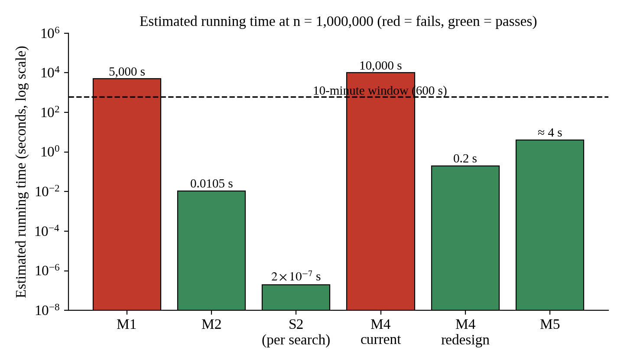
Figure 2: Estimated running time at n = 1,000,000
Modules that fail: M1 and current M4. (The report generator, 3n² ≈ 3 × 10¹², also fails at about 8.3 hours.)
Recommendations
- M1: replace the pairwise loop with a hash table on (seller, title). Θ(n) expected time, about 0.01 s.
- M4: adopt the redesign without replication, Θ(n log n). Keep replication at the storage layer.
- Report generator: redesign to O(n log n) or better.
- M2, S2, M5: no change needed. Use S2 (sorted index) instead of S1 for search.

Code of Conduct
I Divya Prashanth S (Reg. No. 192521361) certify that this submission is my original work and that I have adhered to the guidelines specified for this assessment. I understand that any violation of academic integrity rules will result in disciplinary action.
Signature of the Student: ____________________ Date: ______________

